Mihaell Brenno Alves Klosowski
Renato Silva Machado

Kard Race: Independent Studio Strategies to Computer Games Market

SÃO PAULO
2025

Mihaell Brenno Alves Klosowski
Renato Silva Machado

Kard Race: Independent Studio Strategies to Computer Games Market

Final Course Project submitted to the Institute of Technology and Leadership (INTELI), to obtain a bachelor's degree in Computer Engineering.
Advisor: Prof. Natália Kloeckner

SÃO PAULO
2025

Cataloging in Publication
Library and Documentation Service
Institute of Technology and Leadership (INTELLI)
Data entered by the author.
(Cataloging record with international cataloging data, according to NBR 14724. The record will be completed later, after approval and before the final version is deposited. The completion of the cataloging record is the responsibility of the institution's library.)



Resumo

ALVES, Mihaell; MACHADO, Renato. Kard Race: Independent Studio Strategies to Computer Games Market.. 2025. 26 f. TCC (Graduação) – Engenharia de Computação, Instituto de Tecnologia e Liderança, São Paulo, 2025.

Este trabalho apresenta o plano de desenvolvimento e introdução ao mercado da Non Zero Studios, uma desenvolvedora de jogos focada nos gêneros de estratégia, roguelike e deckbuilding. O objeto de estudo concentra-se na interseção entre mecânicas complexas de construção de baralhos e a temática de corrida, visando atender a uma demanda por inovação em nichos subatendidos na plataforma Steam. O objetivo geral é validar uma solução de jogo e estabelecer um modelo de negócio sustentável para o mercado independente. Para isso, a metodologia adotada baseia-se no desenvolvimento ágil através de sprints, resultando na criação do "Tiny Race" como um Produto Mínimo Viável (MVP) estratégico para a validação de tecnologias de física e inteligência artificial para tomada de decisão. Os resultados dos playtests realizados demonstraram a aceitação do conceito. Conclui-se que a pivotagem estratégica para um cronograma de dois lançamentos, apoiada por um aporte financeiro inicial e um baixo ponto de equilíbrio de vendas, garante a viabilidade econômica do estúdio e reduz riscos tecnológicos, permitindo uma inserção sustentável em um setor de alta demanda global.
Palavras-Chave: roguelike; deckbuilder; steam; desenvolvimento indie; estratégia de mercado.

ABSTRACT
ALVES, Mihaell; MACHADO, Renato. Kard Race: Independent Studio Strategies to Computer Games Market. 2025. 26 f. Final Course Project (Bachelor in Computer Engineering) – Institute of Technology and Leadership, São Paulo, 2025.
This paper presents the development and market entry plan for Non Zero Studios, a game developer focused on the strategy, roguelike, and deckbuilding genres. The object of study focuses on the intersection of complex deckbuilding mechanics and the racing theme, aiming to meet the demand for innovation in underserved niches on the Steam platform. The general objective is to validate a game solution and establish a sustainable business model for the independent market. To this end, the methodology adopted is based on agile development through sprints, resulting in the creation of "Tiny Race" as a strategic Minimum Viable Product (MVP) to validate physics and artificial intelligence technologies for decision-making. The results of the playtests conducted demonstrated the acceptance of the concept. It is concluded that the strategic pivot to a two-release roadmap, supported by an initial financial investment and a low break-even point, ensures the studio's economic viability and reduces technological risks, allowing for a sustainable entry into a high-demand global sector.
Keywords: roguelike; deckbuilder; steam; indie development; market strategy.

List of Illustrations

Figure 1 – [Figure 1 Title]................................................................................page] Figure 2 – [Figure 2 Title]................................................................................page] Figure 3 – [Figure 3 Title]................................................................................page] Figure 4 – [Figure 4 Title]................................................................................page]

Summary

1 Introduction 10
2 [Solution Development] 11
2.1 [Definition of Market Premises and Hypotheses:] 11
2.2 [Market Sizing and Analysis:] 11
2.3 [Competitive Analysis and Differentiators:] 12
2.4 [Technological Solution] 12
2.5 [The Business Plan] 13
2.6 [Validation and Results] 15
3 Conclusion 16
References 16
Appendices 17
Annexes 17

Introduction
The PC gaming industry is undergoing a period of transformation, where the commercial success of independent titles is increasingly linked to the depth of mechanics and the innovation of subgenres. This work presents the strategic and technical foundation of Non Zero Studios, a developer focused on the Strategy, Roguelike, and Deckbuilding niches. The introduction contextualizes the identification of a "blue ocean" in the unprecedented union between racing management and card systems, establishing the objectives and justification for validating this new concept in the global market.

  - Context and Motivation:
Contrary to the common perception of crisis in the game industry, the current scenario for independent studios and small teams can be described as a "Golden Age". We are experiencing the "Great Conjunction" phenomenon, a period in which the most agile development genres align precisely with the consumption desires of players on the Steam platform. This audience prioritizes immediate fun, mechanical depth, and addictive game cycles, being capable of overlooking simple graphics or a lack of extreme polish in exchange for innovative and solid gameplay.
In this scenario, Non Zero Studios positions itself as a PC game developer specializing in Strategy, Roguelike, and Deckbuilding genres. A strategic opportunity was identified by uniting the depth of deckbuilding systems with a racing theme, exploring a niche that market data indicates as "relatively underserved" and with median sales higher than the store's general average.

  - Problem Definition and Value Proposition:
The strategy and roguelike target audience demands systemic depth and the exploration of new subgenres that offer freedom of choice and high replayability. The central problem is the saturation of generic themes and the lack of titles that challenge this player base with unprecedented mechanics.
The value proposition of Kard Race lies in genre innovation through Auto Race management, where the player does not drive directly but makes strategic decisions using cards to sabotage rivals, manage risks, and alter the racing line in real-time. This approach focuses on developing the "fun parts" of the game—systems, concepts, and scenarios—allowing for a faster and more efficient launch that values tactical intelligence over aesthetic cost.

  - Objectives of the Work:
The general objective of this work is to validate an innovative game prototype that integrates racing and roguelike deckbuilding genres, accompanied by the development of a structured business plan for the introduction of Non Zero Studios into the independent games market. To achieve this purpose, the following specific objectives were established:
- Develop fundamental racing simulation technologies and tactical management systems for the initial validation of the auto-racing management concept.
- Develop a Minimum Viable Product (MVP) titled "Tiny Race" to test the technological robustness of physics and AI, foster early community building, and generate initial cash flow for the studio.
- Conduct structured playtest rounds to collect qualitative feedback, allowing for continuous iteration and refinement of the game's core loop.
- Consolidate the business plan by defining revenue models, competitor analysis, and launch strategies for PC platforms.

  - Justification and Contributions:
The relevance of this project is supported by a global market with a combined TAM of $5.3 billion and a projected annual growth of 10.5%. Technologically, the work contributes to the implementation of AI based on Goal-Oriented Action Planning (GOAP), raising the tactical fidelity standard of real-time opponents.
Economically, the solution adopts an agile and efficient development model focused on niches that value intelligent systems. By avoiding the cycle of "suffering for extreme polish" typical of large productions, the studio uses its agility to innovate and take risks, ensuring survival and competitiveness through games with high replay value and lower production costs.

Solution Development
The development of the solution for the Kard Race project is guided by a strategic analysis of the Steam games market, focusing on titles that show high commercial performance and are viable for lean teams. The maximum priority is the delivery of fun, deep, and highly engaging game systems rather than an excessive focus on visual polish or high-cost graphics. This allows Non Zero Studios to use its agility to innovate mechanically, focusing on the Steam player's search for "tactical systems and gameplay depth".

Definition of Market Assumptions and Hypotheses
To align the project with this reality of efficient production, the following premises were defined:
    - Problem Hypothesis
Strategy and roguelike players constantly seek mechanical innovations, new themes, and system depth that offer high replayability. The problem lies in the saturation of generic themes within these genres; it is assumed that this audience is willing to pay for unprecedented subgenres that prioritize complex tactical decisions over high-cost productions with realistic graphics and linear content.
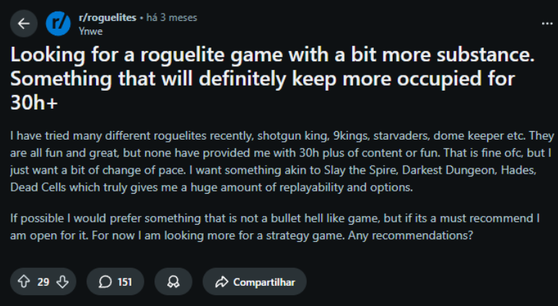

    - Solution Hypothesis
The unprecedented mix of Roguelike Deckbuilding with AutoRace management is a unique solution to deliver the novelty and system depth that the target audience demands. By automating driving to focus on card strategy, rival sabotage, and real-time risk management, the game ensures a highly engaging gameplay cycle with a wide diversity of possible strategies.

    - Value Hypothesis
It is assumed that the Premium revenue model (pay-to-play) is widely accepted by this niche, given that games with high replay value reduce the cost per hour of entertainment for the player. The market value is validated by the fact that the Roguelike Deckbuilder niche on Steam has a higher median sales rate than the store average and is considered "relatively underserved".

Market Sizing and Analysis
Market sizing is a vital step in proving the economic viability of the project on a global scale. Through TAM, SAM, and SOM metrics, this section quantifies the financial potential at the intersection of the Roguelike and Racing markets. Additionally, a detailed profile of the target persona is presented, analyzing consumption habits and gameplay preferences that validate Kard Race's value proposition. All values ​​are estimated in dollars by default.
    - Market Size (TAM, SAM, SOM)
- TAM (Total Addressable Market): Valued at $5.3 Billion in 2024, combining the global Roguelike ($3.2B) and Racing ($2.1B) markets
- SAM (Serviceable Addressable Market): Focused on Steam (PC), totaling $1.616 Billion, composed of the revenue from the Roguelike Deckbuilder ($1.1B) and Racing ($516.3M) niches over the last 3 years.

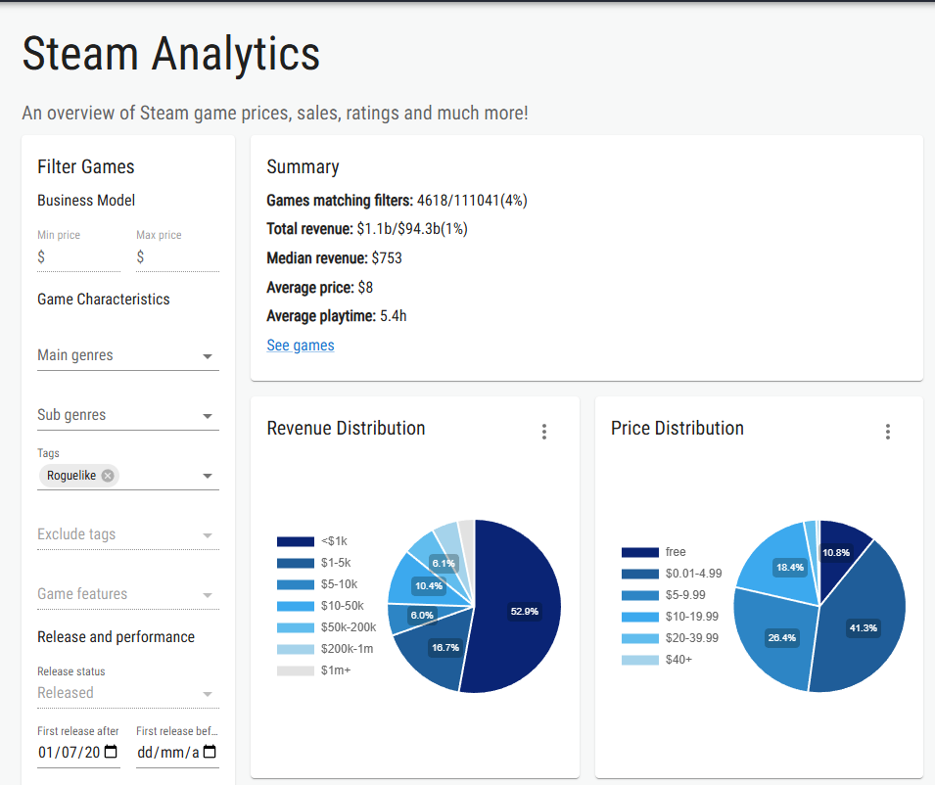
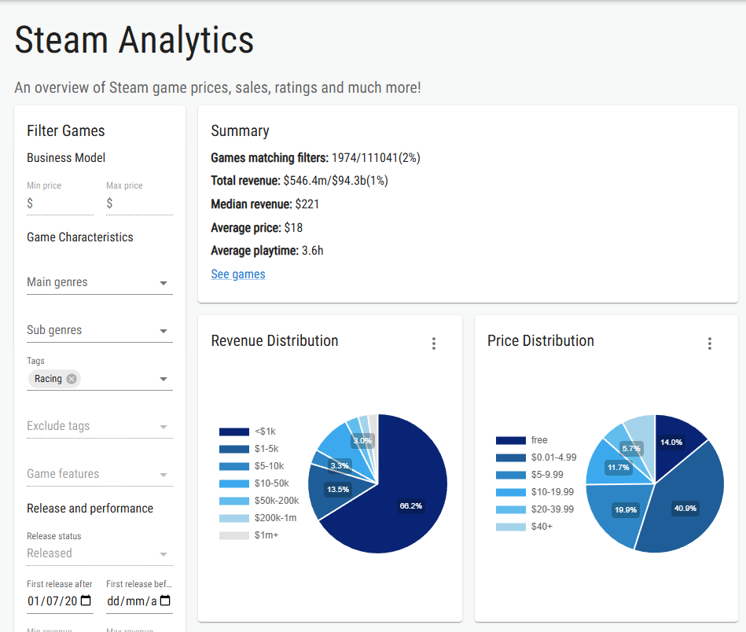

- SOM (Serviceable Obtainable Market): Initial goal of capturing 0.1% of the combined SAM, projecting a revenue of $1.6 Million.

    - Customer Segmentation and Profiling
Non Zero Studios' market segmentation focuses on a niche of gamers who prioritize tactical depth. The target audience comprises strategy enthusiasts seeking new ways to engage with classic genres.
- General Profile: Players with a profile focused on strategic challenges and high replayability. They are consumers of established titles such as Slay the Spire, Balatro, and Art of Rally.
- Age Range: Young adults between 18 and 30 years old.
- Persona: Lucas Ferreira.
  - Age: 22 years old.
  - Occupation: University student who balances his routine between studies, friends, and games.
  - Interests: Card games (Hearthstone), racing games, and roguelikes.
  - Consumption Behavior: Lucas prefers experiences that allow him to experiment with different combinations and refine tactics.
  - Although he appreciates relaxing moments, he does not avoid challenges and values the progression and constant adaptation present in games like Hades and Risk of Rain 2.
  - Need: His ideal game combines accessible mechanics with a rewarding learning curve, allowing for both casual matches and deep dives into more challenging experiences.

Competitive Analysis and Differentials
In an ecosystem saturated with releases, competitive differentiation is the main pillar of survival for an independent studio. This analysis compares Kard Race with direct competitors in the deckbuilder genre and indirect competitors in racing management. The text highlights how the implementation of proprietary technologies and the unprecedented fusion of genres create entry barriers for competitors and establish a unique position in the market.
Principais Competidores:
- Direct (Mechanic/Genre): Balatro ($73.1M), Astrea ($6.1M), and 9Kings ($8M) in the deckbuilder niche.
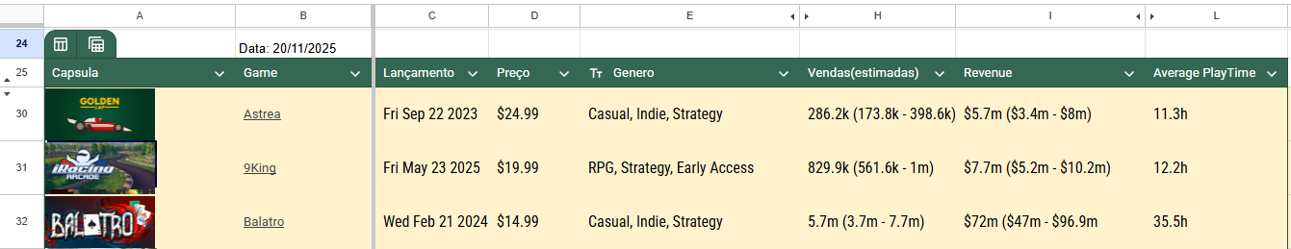
- Indirect (Theme/Management): Circuit Superstars ($1M), GoldenLap ($371.1k), and GT Manager.
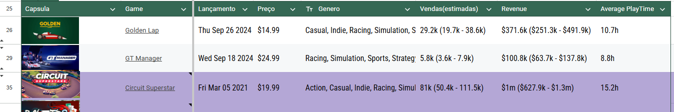
Competitive Differential: The Kard Race project establishes itself in a "blue ocean" by uniquely unifying real-time racing management with "Deckbuilding Roguelike" mechanics. Unlike traditional titles, the competitive differential lies not only in the theme but in the offer of a new category of gameplay for strategy enthusiasts.
- Mechanical Innovation for Strategists: The game meets the demand for systemic depth and new subgenres, replacing the focus on ultra-realistic graphics with complex systems of tactical decision-making and risk management.
- Exploration of an Underserved Niche: Market data indicates that the Roguelike Deckbuilder niche on Steam has a median of sales higher than the store average, being considered "relatively underserved".
- High Replayability and Efficiency: The use of procedural generation (in different rivals, cards, and objectives) and permanent death (permadeath) guarantees a long-lasting experience with an optimized production cost, focusing on what the hardcore audience values: mastery of the game system.
- Entry Barrier via Technology: The implementation of advanced AI through Goal-Oriented Action Planning (GOAP) creates challenging opponents that interact with the cards strategically, raising the level of competitiveness and simulation fidelity.

Technological Solution
The technological solution of the project was architected to sustain complex systems in a scalable and efficient way. This section describes the functional and non-functional requirements, detailing the choice of the Unity 3D engine and the FMOD audio middleware. Furthermore, the development schedule divided into modules is presented, which organizes the implementation of critical technologies, such as vehicle physics and deck logicmódulos, que organiza a implementação de tecnologias críticas, como a física de veículos e a lógica de baralhos.

    - Architecture and Technology:
The project uses established tools in the independent industry to ensure stability and portability:
- Engine: Development is carried out in Unity 3D, allowing for efficient management of racing physics and the user interface (HUD) necessary for the deckbuilding system.
- Audio: FMOD middleware is used for the implementation of dynamic soundtracks and sound effects (SFX) that react to card actions and the race state.
- Artificial Intelligence (AI): The innovative implementation is based on Goal-Oriented Action Planning (GOAP), allowing rivals to make complex strategic decisions, such as choosing the ideal moment to sabotage the player or manage their own resources.

    - Development and Implementation (MVP):
The development of the project is guided by an agile methodology, using Sprints focused on the incremental delivery of technical and design modules. The production strategy was divided into four main modules for the construction of the Minimum Viable Product (MVP):
- Module 1 - Planning and Foundation: Focuses on structuring the business model through the Business Model Canvas and preliminary analysis of the target audience. It includes communication planning and the preparation of materials for events, such as the pitch deck for Gamescom Latam.
- Module 2 - Core Loop and Racing Systems: Implements vehicle physics, basic navigation, and inventory logic to track the player's state. It establishes card mechanics integrated into vehicle attributes and the A* algorithm for dynamic pathfinding.
- Module 3 - Advanced Mechanics and AI: Introduces the racing HUD with real-time information. It establishes the implementation of GOAP AI (Goal-Oriented Action Planning) for complex decision-making. It includes the integration of visual effects (VFX) and sound (SFX).
- Module 4 - Validation and Go-to-Market: This phase focuses on preparing the project for the market through five strategic steps. It begins with the refinement of the pitch deck focused on the game vision and investment proposal. It proceeds to the development of a full game cycle prototype to validate the main flow and the implementation of a functional build with a basic user interface and visual identity. The module advances with external playtests to collect feedback and adjust gameplay, ending with strategic research of festivals and events for project exposure in 2026.

    - Testing and Technical Evaluation:
For the technical evaluation of the project, the primary focus lies on conducting audience playtests, which serve as the central tool for collecting qualitative and quantitative feedback. The first testing cycle occurred last year during the EAI Jogos event, where the basic concept of a game uniting automatic racing and deckbuilding was validated. The second testing cycle was conducted with Tiny Race during the Sampa Games acceleration program, focusing specifically on validating management mechanics and racing physics, without including the card system at this stage. These sessions with the public allow for adjusting balance, the difficulty curve, and navigation fluidity. As a result, the goal is the stabilization of the fundamental dynamics of the game (Core Loop) and the validation of the performance of the GOAP artificial intelligence, ensuring that opponents present a challenging behavior in response to user decisions

The Business Plan
The business plan for Non Zero Studios defines the path to the studio's financial sustainability through an optimized development model. The strategy focuses on creating games with a high replayability factor, allowing competition with larger budget productions through mechanical depth. This section details the structure of operations, costs, and strategic partnerships that ground the studio's entry into the independent market.
    - Market and Competitor Analysis:
As an integral part of the business plan, this analysis uses tools such as the SWOT matrix to evaluate internal strengths and weaknesses against industry opportunities. The focus lies on exploring the expansion of the Roguelike market and the underserved niche of deckbuilders on Steam, using the racing thematic differential to attract a loyal and engaged player base.
SWOT Analysis:
- Strengths: Mechanical innovation by creating a new subgenre (Blue Ocean) and efficient development model with low production cost in relation to player retention time.
- Weaknesses: Reduced technical team and visibility barriers (discoverability) on platforms with a high volume of daily releases.
- Opportunities: Expanding Roguelike market (10.5% CAGR). The Roguelike Deckbuilder niche is considered "relatively underserved" on Steam, presenting median sales higher than the average.
- Threats: Saturation of generic titles in the Roguelike genre and indirect competition from established large racing franchises (AAA).
Differentials:
- Kard Race positions itself as the first Racing Card Game to fuse deck building (Deckbuilding) with tactical real-time racing management.
- Unlike traditional fantasy Roguelikes, the project uses a post-apocalyptic racing theme to deliver the mechanical innovation that strategy players seek.
- The game replaces direct driving with high-level decision-making, using Roguelike mechanics to offer a diversity of strategies and combinations in each match.

    - Business Model (Business Model Canvas - BMC):

Customer Segments: PC players (Steam) interested in strategy, management, and roguelites.
Value Proposition: Deep strategy games with high replayability and an unprecedented post-apocalyptic racing theme.
Channels: Steam (main), social media (Reddit, Instagram), Discord, and niche influencers.
Revenue Sources: Premium model (sale per copy) with a projected price of $20 for Kard Race.
Key Activities: Software development, deck mechanics design, and community-focused marketing.
Cost Structure: Team salaries, licenses, marketing, and outsourced audio and art services

    - Marketing and Sales Strategy:
Non Zero Studios' marketing and sales strategy was refined to mitigate risks after receiving a R$ 50,000 investment through the Sampa Games program. The launch plan, or Go-to-Market, was divided into two fundamental stages: first, the launch of Tiny Race in the third quarter of 2026, a project with a reduced scope focused on validating physics and artificial intelligence technologies, in addition to generating cash flow and initiating the formation of a community. In a second stage, scheduled for 2028, the launch of Kard Race will occur—the complete product aimed at the hardcore audience—which will be preceded by the availability of a demo version for festivals in 2027.
Regarding customer acquisition and retention, the studio will focus its efforts on establishing partnerships with small and medium digital influencers specializing in deckbuilding games. Furthermore, the marketing strategy prioritizes active participation in major in-person industry events, such as Gamescom Latam, aiming for direct validation of the product with the public and strengthening community engagement.

    - Financial Projection and Feasibility:
Financial viability and project projections are structured within a sustainable business model, focused on cost efficiency and realistic sales targets. The price and revenue structure is divided into two stages: for Tiny Race, the target is the sale of 17,000 copies to generate a net revenue of $120,000; whereas for Kard Race, the objective is to reach 100,000 copies, aiming for a net revenue of $1 million.
Regarding viability and the break-even point, the total cost for the development of the complete game and studio maintenance for an 18-month cycle is estimated at R$ 341,334.00. The project's break-even is considered low and highly achievable: with the sale of only 8,000 copies—which represents approximately 15% of the average sales of niche competitors—the main project already reaches its financial equilibrium.
As for investment needs, the initial contribution of R$ 50,000 obtained through the Sampa Games program is intended for financing technological validation and the initial production stages. For subsequent phases, the studio plans to seek additional resources through audiovisual public calls and strategic partnerships with publishers, using the delivery of the Vertical Slice as the primary negotiation tool.

Validation and Results
Project validation consisted of continuous market and usability testing, involving direct interactions with the public and industry curators. This section describes the methodology applied at renowned events and specialized forums to collect qualitative feedback. The presented results justify the studio's strategic decisions, such as pivoting the roadmap to mitigate technological and financial risks before the final launch.
    - Validation Methodology:
For the validation of business hypotheses and MVP acceptance, Non Zero Studios used a methodology based on direct exposure and interaction with specialized communities. The project was tested with the public and industry experts through participation in EAI Jogos, the TrovaLab incubation program, and, more recently, at Sampa Games acceleration events. These participations allowed for collecting real-time feedback and validating the game's differential for investors and players. Additionally, the studio used specialized forums, such as Reddit, to validate interest in a "Racing Roguelite," collecting qualitative reactions regarding game mechanics and artistic style directly from the target audience.
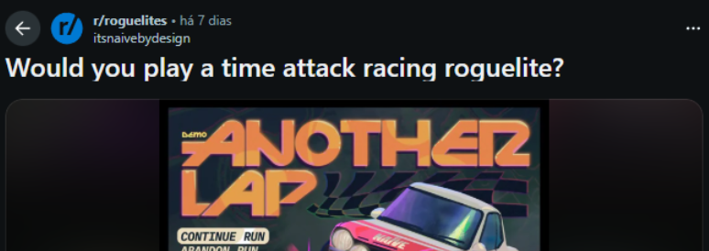
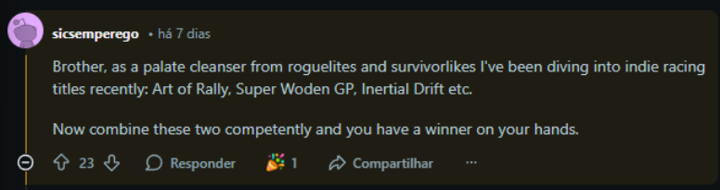
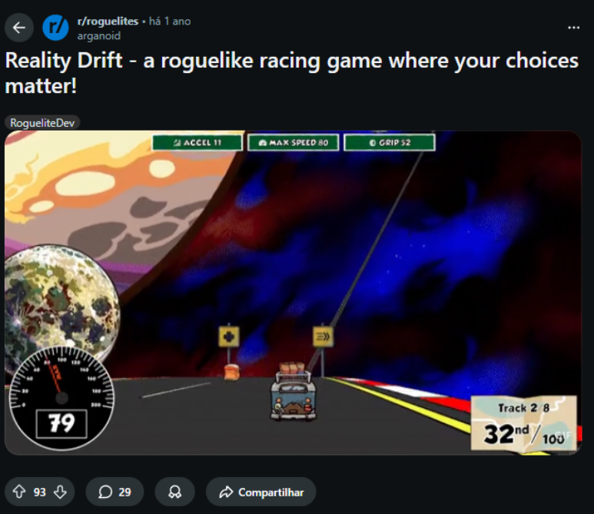
    - Market Validation Results:

The market validation of the project demonstrated that the value proposition is solid, with users confirming the originality of the genre mix and highlighting that the combination of arcade elements with roguelite mechanics results in an "addictive" game loop and a true "blue ocean". In terms of engagement and institutional recognition, the project was selected as a highlight in the TrovaLab incubation program and secured participation in Gamescom Latam, which evidence a high acceptance by curators and industry experts.
Based on this feedback and after the R$ 50,000 contribution received through the Sampa Games program, the team performed a strategic pivot in the roadmap. Instead of advancing directly to the launch of Kard Race, which has greater complexity, it was decided to develop and launch "Tiny Race" first in the third quarter of 2026. The objective of this new strategy is to validate physics and AI technologies, mitigate financial risks, and start building an active community before the delivery of the final product

    - Key Performance Indicators (KPIs):

For the management and monitoring of business success, key performance indicators focused on sustainability and growth were defined. The Customer Acquisition Cost will be optimized through an organic and targeted marketing strategy, prioritizing partnerships with small influencers in the deckbuilder and roguelike niches, in addition to a strategic presence at Steam festivals to maximize visibility with low direct investment.
The Retention Potential and the Lifetime Value are grounded in the high replayability factor provided by procedural generation, with expectations based on competitor benchmarks that present an average playtime between 10 and 30 hours per user. Finally, the studio's financial viability is linked to clear conversion and sales volume goals, established at 17,000 copies for the initial launch of Tiny Race and 100,000 copies for the main product, Kard Race.

    - Risks and Mitigation Plan:
To ensure project resilience in the face of the independent gaming sector's uncertainties, a risk mitigation plan focused on an incremental development strategy was structured. The primary market risk, Roguelike genre saturation, is mitigated by mechanical innovation through merging the genre with a racing theme, creating a new "blue ocean" category that avoids direct competition with established titles. To combat discoverability challenges and high acquisition costs, the strategy focuses on the potential of content creators and building a solid community before the main launch.
In the technological sphere, risks associated with the complexity of vehicle physics and artificial intelligence are addressed through the strategic launch of Tiny Race. This smaller-scope project acts as technical and financial validation, allowing for the stabilization of GOAP AI systems and the gameplay core loop before large-scale investment in Kard Race. Financially, the risk of low return is reduced by a conservative break-even point, where the sale of just 8,000 copies—roughly 15% of competitors' average—already guarantees project repayment, protecting Non Zero Studio's economic health.

Conclusion
The analysis and development of this project demonstrate the technical and commercial viability of Non Zero Studios in the competitive independent games market. By identifying a "blue ocean," the studio positions Kard Race not merely as a racing game, but as an innovation within the strategy and roguelike deckbuilding genres, meeting a demand for mechanical depth and high replayability in high-demand niches on the Steam platform.
The market strategy matured significantly through participation in the Sampa Games acceleration program. The R$ 50,000 contribution allowed for a smart roadmap pivot, prioritizing the launch of Tiny Race as a fundamental validation stage. This approach enables the studio to test critical physics and artificial intelligence technologies and begin building an active community, mitigating financial and technical risks before the full product launch in 2028.
Results obtained in the testing cycles—from conceptual validation at EAI Jogos to management mechanics tests during acceleration—prove the acceptance of the value proposition by specialists and the public. With an accessible break-even point and an efficient production model that prioritizes intelligent systems over high-cost aesthetics, the project contributes to strengthening the independent development ecosystem. In summary, the union between technological innovation and data-driven risk management positions Non Zero Studios for a sustainable and promising entry into the global digital games market

References

